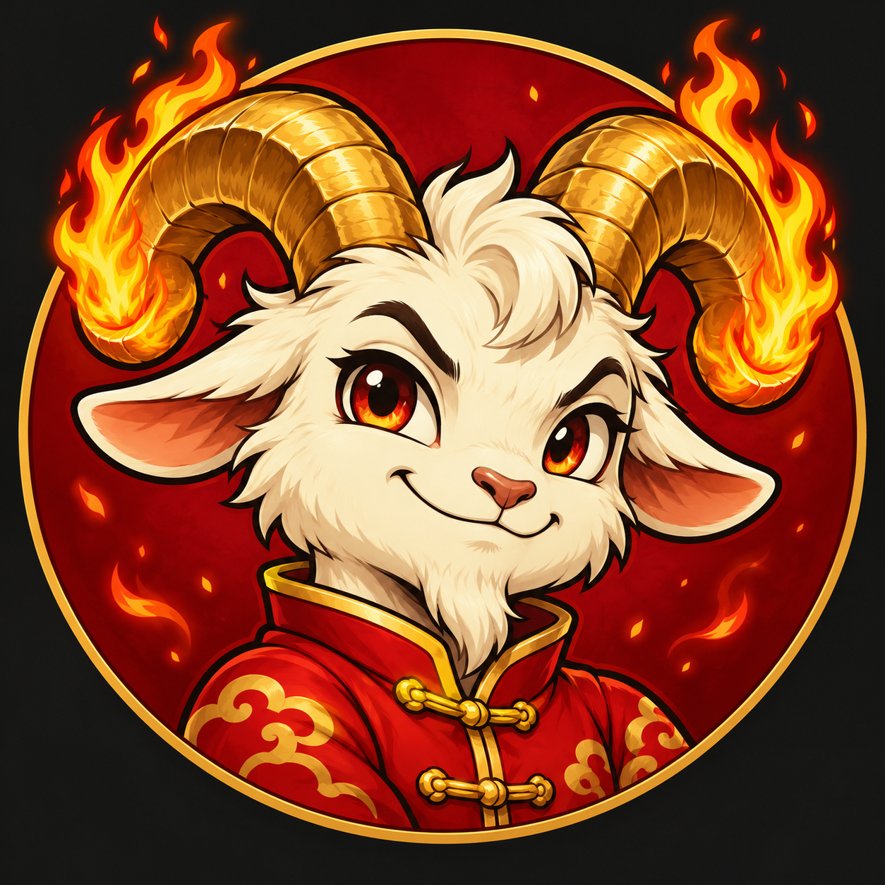

FIRE GOAT Launch Copy and Publication Plan
  - FIRE GOAT | FGOAT | Launch edition | 5 October 2026
This pack provides public launch wording and a separate release checklist. Replace bracketed fields with verified launch details. Publish claims about reward activation only after the corresponding token settings and settlement service have been verified.

Pump fun description
FIRE GOAT brings the herd together around Ember, a little goat with flaming horns and an adventure that keeps growing. One day. One fire jump. Explore the daily trail, care for your goat, collect outfits and challenge the candles. Built for the long term on Solana, with Pump.fun Holder Rewards as our launch fee model. Hold 100,000 FGOAT for the garden and daily Mystery Boxes, or 1,000,000 for ordinary Candle Run access. Website: https://firegoat.xyz | X: @FireGoat_Ember

Short project description
FIRE GOAT is a Solana community meme coin starring Ember. Follow an ongoing daily trail, care for your goat, collect outfits and play skill games. A growing world for the herd, with Pump.fun Holder Rewards as the launch fee model.

Launch announcement
FIRE GOAT has launched on Solana. Meet Ember and join a world built to keep growing: a daily fire trail, a cozy holder garden, collectible outfits and goalkeeper and candle challenges.
Official CA: [OFFICIAL_CA]
Pump.fun: [OFFICIAL_PUMP_FUN_URL]
Dexscreener: [OFFICIAL_DEXSCREENER_URL]
Website: https://firegoat.xyz
X: https://x.com/FireGoat_Ember
Discord community: https://discord.gg/nxUqYdkhK
Instagram: https://www.instagram.com/firegoat_ember/
Hold at least 100,000 FGOAT for the holder garden and one Mystery Box per UTC day. The first claimed box gives a bed; the second gives a TV. Hold at least 1,000,000 FGOAT for ordinary Candle Run access, or earn a three-life pass with seven consecutive goals.
Our launch selects Pump.fun Holder Rewards: the creator-fee portion goes to eligible holders through Pump.fun’s automatic distribution. Game rewards and item redemption are separate and become payable only after their funded settlement service is activated. Market values and rewards are not guaranteed. One day. One fire jump.

Community answers

Does the project end after one year
No. Each 365-space trail continues into a new segment. FIRE GOAT follows a long-term growth narrative with no annual finish line.

How do daily Mystery Boxes work
Eligible wallets holding at least 100,000 FGOAT can open one free box per UTC day, shared across the home page and garden. The first claim gives a bed, the second gives a TV, and later claims draw from the gift catalog. Duplicate copies are possible.

What happens if I sell and buy back
Access pauses when the balance falls below the threshold. Rebuy enough tokens and reconnect to restore eligibility. The garden and claim history remain associated with your wallet; welcome gifts do not restart, and neglect rules still apply.

How are holder rewards different from game rewards
Pump.fun automatically distributes its Holder Rewards under its own rules. Garden items are collectibles. Candle and wheel token prizes, and item redemption, require a separate funded settlement service. The website holder thresholds do not set Pump.fun reward eligibility.

When does Candle Run award tokens
Levels last 50 clears. Level 3 is the eligibility gate, but token milestones occur every 500 consecutive clears within one run. Each records 1,000 FGOAT, or 2,000 when Golden horns is active at that milestone. Settlement follows the published payout activation and verification rules.

Can I play below one million tokens
Yes, if you hold at least 100,000 FGOAT and score seven consecutive goals. That earns a limited three-life pass. When its lives are used, earn another pass. Extra lives and rebirths do not extend this pass.

Where can I find official information
Use https://firegoat.xyz and https://x.com/FireGoat_Ember. Verify the CA against the official token page before trading. Terms and privacy are linked from the website footer. No support representative needs your seed phrase.

Internal release checklist
This page is for the project team. Keep it separate from public announcements. The documents describe the launch design without test-mode messaging; they do not certify that unactivated features are already live.

Token and market connection
- Create the official token and confirm the Holder Rewards setting on-chain or on the official Pump.fun token page before using the launch announcement.
- Replace [OFFICIAL_CA], token URL and Dexscreener URL throughout the website, app, documents and pinned community posts.
- Confirm supply, decimals, mint and freeze authority, creator holdings, allocations, liquidity, locks and any vesting. Publish exact facts; do not assume zero team allocation or renounced authorities.
- Connect the official mint to holder checks and live market history. Set the trail’s day-one epoch to the actual launch date; the current source uses a fixed preview day offset.
- Verify inclusive balance gates at exactly 100,000 and 1,000,000 tokens, selling below them and regaining access after rebuying.

Reward activation and consistency
- The current game source explicitly reports payoutReady false. Build and fund settlement before announcing direct wallet game payouts or item sales.
- Publish the separate reward reserve, payout timing, validation, fees, limits and handling of reserve exhaustion. Do not count Pump.fun holder fees as team funding.
- Confirm one shared daily box claim, first bed and second TV, UTC resets, inventory persistence and no welcome-gift restart.
- Decide whether Wheel Day is intended for 100,000 holders or only 1,000,000 holders. The current saved wheel route requires full Candle Run access; this guide records that behavior.
- Check the 92.2% no-prize wheel total, 50-clear levels, 500-clear token milestones, 5 active plus 2 spare lives, optional rebirths and three-life pass limits.
- Disable public testing bypasses at release and update terms and privacy to match the activated service, actual operator and published reward conditions.

Publishing and ongoing operations
The official Discord invite and Instagram profile are included above. Confirm Activity verification and Discovery status before claiming public Discord availability. Test mobile, desktop, installed app, Space controls, portrait downloads and saved state. Publish launch copy only after the token exists. Announce game reward activation separately when settlement is ready. Monitor holder access, claim errors, game validation and reserve balances after release.

